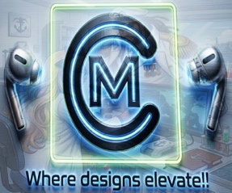Garland J. BENNETT, III
9551 Brentwood Dr. Apt#124 La Vista, NE | | 402-320-5208 | My Creative Agency | Stage32 Profile

Skills Summary
I’m a highly skilled, experienced, and professional graphic novelist, comic writer, screenwriter, graphic/web designer, storyboard artist, actor, musician, and sound engineer. Senior Digital Art Director with a master’s in digital media design and 10+ years of experience steering visual identities for diverse portfolios. Proven record of accomplishment in scaling brands through multi-channel campaigns, high-fidelity storyboarding, and AI-integrated creative workflows. Looking to leverage deep expertise in lifestyle and environment-based branding to lead the in-house creative team at Hurrdat Media. “Celestial Graphics & Media,” formerly an agency called “Celestial Graphics,” is a start-up agency that started in the Summer of 2013. Starting as a Jr. Graphic Designer, I took on projects and campaigns from many clients in the past. Nowadays, into the 2020’s, it has services in video-editing, graphic/web design, & music videos to add.

Education

Master of Fine Art in Game & Interactive Media Design | Full Sail University| December 2019
  - I use computer programs to develop visual materials. These include images, branding, animations, and/or special effects for a variety of mediums, including films, advertisements, websites, publications, social media, and video games. I communicate through electronic devices, such as a computer, tablet, or mobile phone.
- Bachelor of Arts in Art Management w/ conc. in Graphic/Web Design| Midland University | May 2013
  - Create and support websites. I learned to create the site’s technical aspects, such as its performance and ability, which measures the website’s speed and how much traffic the site can handle. I also create content for the website to add. I also added an entertaining web series, in which I get paid through Google AdSense.

Associates of Science in Media Studies; Digital Communication Arts | IWCC | July 2010

It involves content creation, analysis, and management of media for business. Shoot videos, record audio, design content, and use social media for engagement. Getting into careers like Social Media Marketer, Videographer, Audio/Video Producer, Web Designer, and Graphic Designer.

Experience

Celestial Graphics & Media, LLC. 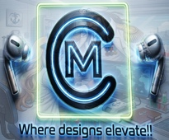

Sr. Digital Designer & Digital Art Director | Feb 2017-Present
  - I design layouts and advertising copies, edit scripts, audio, video, and other promotional materials to ensure they meet specifications. Additionally, I plan and implement advertising policies and strategies for organizations.
  - I check and evaluate sales promotion outcomes to assess the cost-effectiveness of campaigns. I create communication materials, advertisements, presentations, and public relations efforts to raise awareness about products and services.
  - I use social media sites like Tik-Tok, Instagram, and Meta to market my business and reach as many audiences as possible.

- Hillcrest Health & Living. 
  - Cook | April 2019-July 2026
  - As a Cook & Server at Hillcrest Health & Living, I handle preparing a variety of special meals tailored to the dietary needs and preferences of the residents. In addition to the main menu offerings, I also create alternative meal options to ensure that every resident has access to meals that accommodate their specific requirements and tastes. My role involves both the preparation and serving of these meals, ensuring that each resident receives high-quality and nutritious food in a welcoming environment.

Awards and Acknowledgements
- Track & Field Coach Diploma
- Adobe Art Directing certificate
- Hillcrest Great Customer Service Award ‘19
- NaNoWriMo Winner ‘16
- Coursera Advanced Social Media Strategy Training & Certification
- Coursera Advance Digital Marketing Certification

