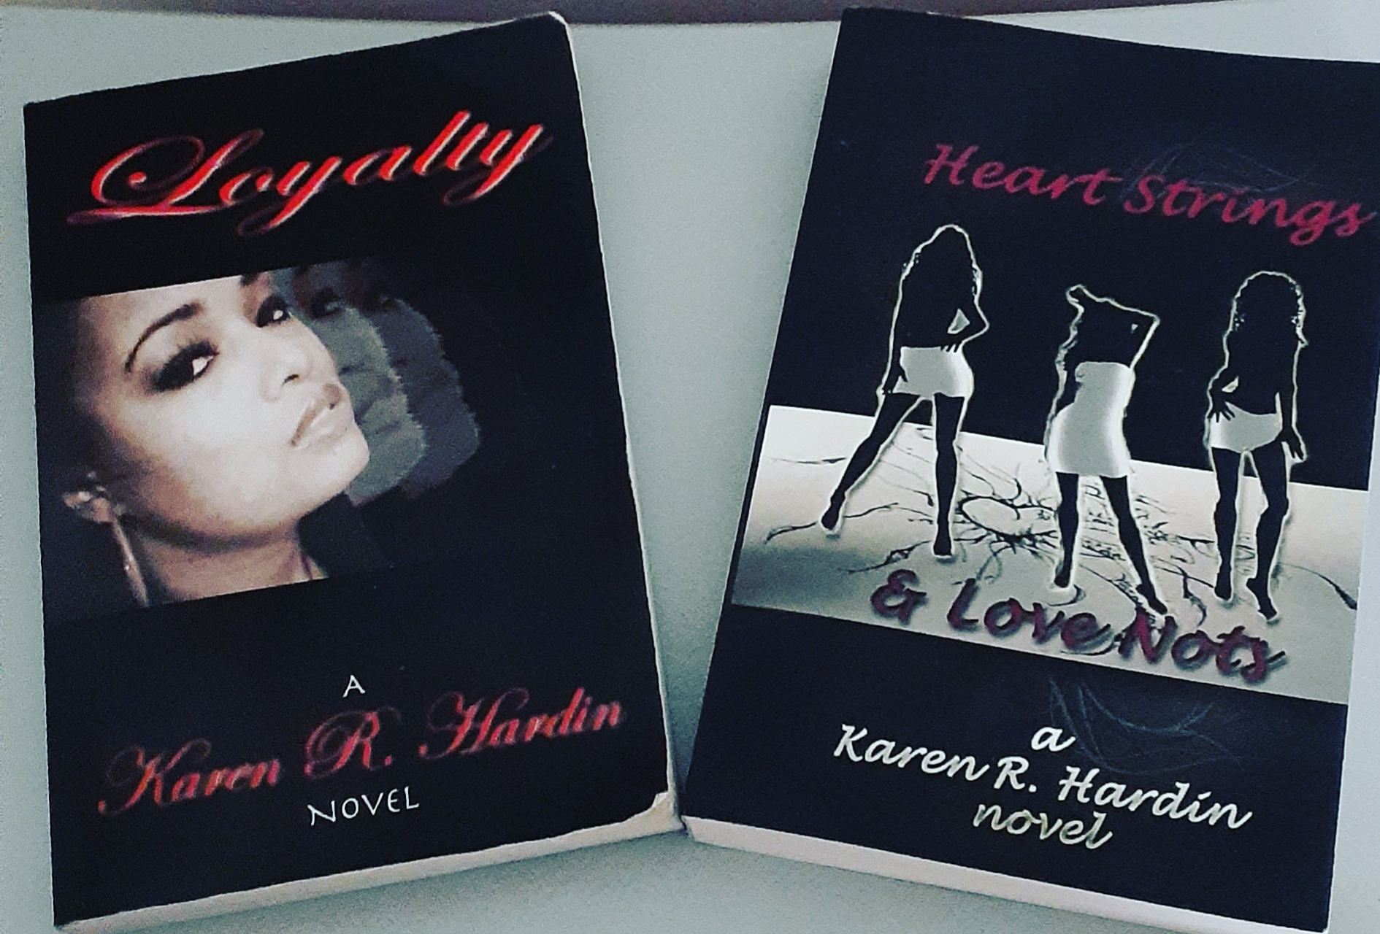 |  | Karen r. Hardin  Author/Screenwriter
Profile  Karen R. Hardin is the author of two novels entitled “Loyalty” and “Heart Strings & Love Nots”. She has been penning creative works for herself and others for over 20 years. Her work spans from Mafia to romance to suspense to comedy.  Karen lived in Los Angels for 3 years working with Indie producers and learning to write for production. She has since returned to and resides in North Carolina where she grew up and is focus on writing for Mega Mind Media working directly with award winning CEO and Film Producer Tressa Arzeal Smallwood and writing for St. Louis based UCME Entertainment working directly with Grammy Winning CEO/Rapper Robert “Kyjuan” Clevland.  Contact  PHONE:  919-757-7695  EMAIL:  KarenRHardin2@gmail.com  Hobbies  Story Development  Social Media  Dance  Writing |  | EDUCATION  Clark Atlanta University  1992 - 1993  Study mass media communications for one-year learning media production.  Enloe High School  1990 - 1992  Attended Enloe High School for the Gifted and Talented for 2 years after attending Broughton High School and Millbrook High School where she was a cheerleader.  WORK EXPERIENCE  Mega Mind Media - (Writer)  March 2018–Present  Story Development, Adapting Novels to Script, Writing TV Show Bibles, Writing TV Movie Scripts, Creating Movie Indexes, Writing Screenplays and Teleplays “The Available Wife”, “Kiss of Death”, “Dying to be Famous” Blood Wars”  Self-Published - (Publisher/Author)  2001–Present  Wrote and published “Loyalty” and “Heart Strings and Love Nots” through Ingram Print on Demand, then transitioned to Amazon E-Books  Freelance Screenwriter - (Writer for Various Indie Producers)  2000 – Present  Story Development for Movie and Television Concepts, Writing Screenplays and Teleplays for Robert “Kyjuan” Clevland of the St. Lunatics and UCME Entertainment  SKILLS  Story Development, Story Indexing, Concept Creation, Character Development, Outlining, Scripting for Production, Television and Stage, Cover Design, (some Pitch Deck Design work)

