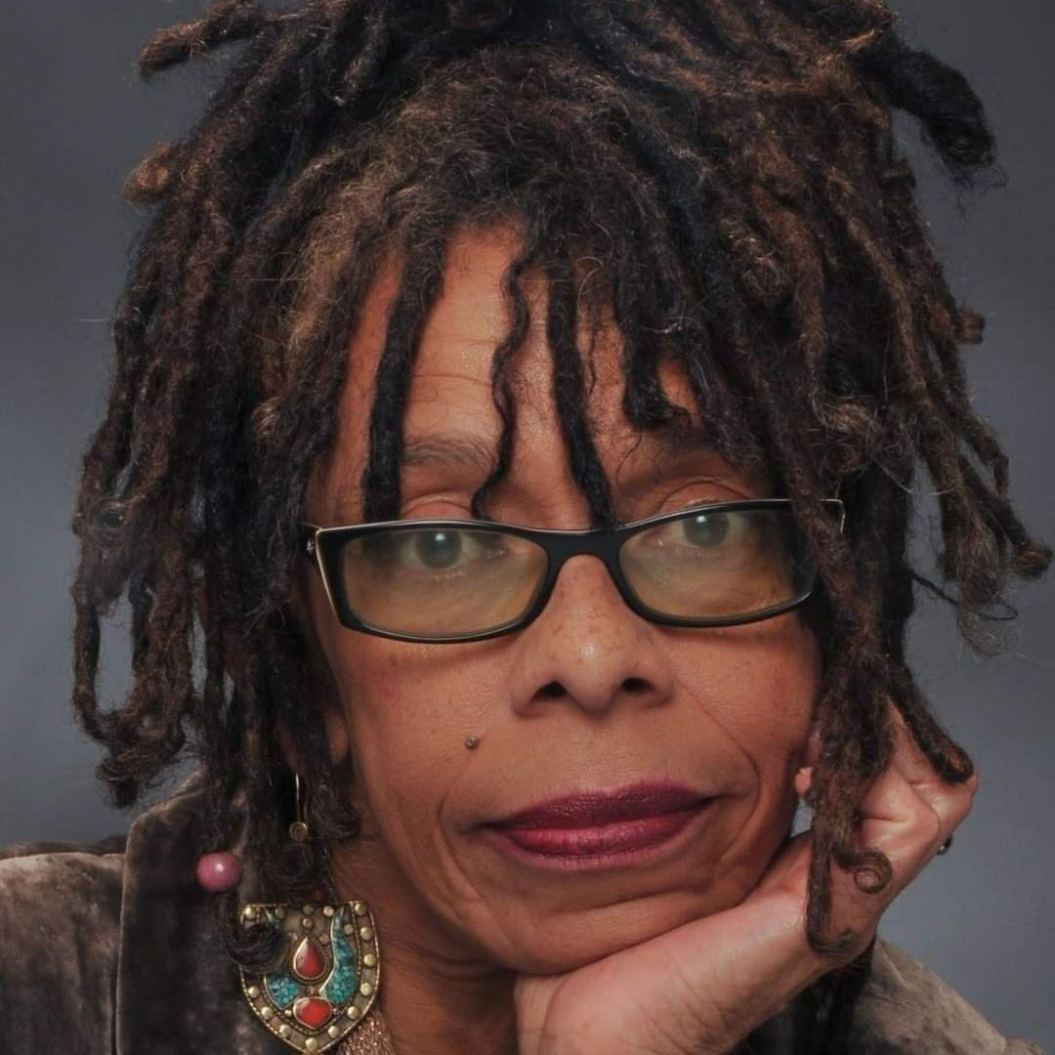 |  | EDUCATION

University of North Carolina at Wilmington
January 1997 – May 1999
Completed two-year program and grad exam in UNCW's Creative Writing Graduate School
Developed master's thesis, a screenplay and critical study of Wilmington's White Supremacist Massacre & Coup D'Etat (then transferred back to East Carolina University May 1999)

East Carolina University
September 1994 – May 1999
1994-1996 Completed two-year graduate school degree in Creative Writing and Multicultural Literature
1999 Returned to ECU: defended, with honors, a double master's degree in Screen Writing and Multicultural Literature.

alicia inshiradu  Screen Writer Seeking Representation  Profile  Recent coverage of What The River Knows, a 120-page multigenerational, supernatural mystery, sees “elements of Beloved by Toni Morrison and Cassie Lemmon’s Eve’s Bayou, while crafting a wholly original Southern Gothic palette though What The River Knows is more subdued and literary in tone.” Having written, produced and directed four short films and two other shorts, not yet produced, I am currently, developing my next feature - The Last Fear (a fantasy) – as I ready What The River Knows to be shopped around the industry.  CONTACT  PHONE: 910-262-3199  WEBSITES: Playingod Films Presents  www.facebook.com/ILMfilmmaker  What The River Knows, the short film teaser  https://www.facebook.com/whattheriverknows/videos  What The River Knows, the future feature inspired by 1898 Wilmington  https://www.facebook.com/whattheriverknows  EMAIL: playingodfilms@gmail.com |  | WORK EXPERIENCE

Playingod Films Presents: Founder, CEO
January 2001–Present
Screen Writer, Filmmaker, Playwright, Producer, Director
Original Film Scripts, Short Films, Plays:
What The River Knows (adapted film script as a stage play for the live stage 2022)
What The River Knows (feature script 1999, short film teaser 2019)
When Florence Came To Wilmington (short documentary 2019)
Northside Alley (short film, drama 2018)
Blind Date (short film, drama 2016)
Dream Man (short film 2015, unproduced)
Meltdown (short film 2015, unproduced)
Dance of Redemption (stage play 2001)
The Man Who Loved to Laugh (African tale, children’s stage play adaptation 2001)

Narrative Arts, Inc: Filmmaker
July 2019–November 2019
Wrote, produced and directed When Florence Came To Wilmington (short documentary on Hurricane Florence 2019); interviewed residents

Cucalorus Film Festival: Short Films Programmer
June 2022 – present
View and rate over 100 short films each summer season, (dramas and documentaries) for Cucalorus, an international film festival held every November in Wilmington for the last 30 years.

Cape Fear Community College: College Instructor
August 2004-January 2014
Taught college-preparatory courses: English Composition; Introduction to Literature; Creative Writing; Argument-Based Research; African-American Literature; Critical Thinking Task Force Committee.
Early-retired in 2014 to found Playingod Films Presents.

awards, grants, coverage, &

film festivals
Quarter-Finalist: Wiki Screenplay Contest (July 2025)
Wiki Screenplay Contest Coverage Analysis
Best Local Independent Film (for What The River Knows, Encore Magazine 2020)
First Prize, ECU Literary Journal for Chosen, a short story
Cucalorus Film Festival (Wilmington): Blind Date, What The River Knows, Northside Alley
100 Words Film Festival (Charlotte, NC): Blind Date
NC Black Film Festival (Wilmington): Blind Date
Grassroots Grant Arts Council of the Lower Cape Fear to complete What The River Knows short film teaser (2017)
Grassroots Grant from New Hanover Arts Council for Dance of Redemption, a stage play (2001)

