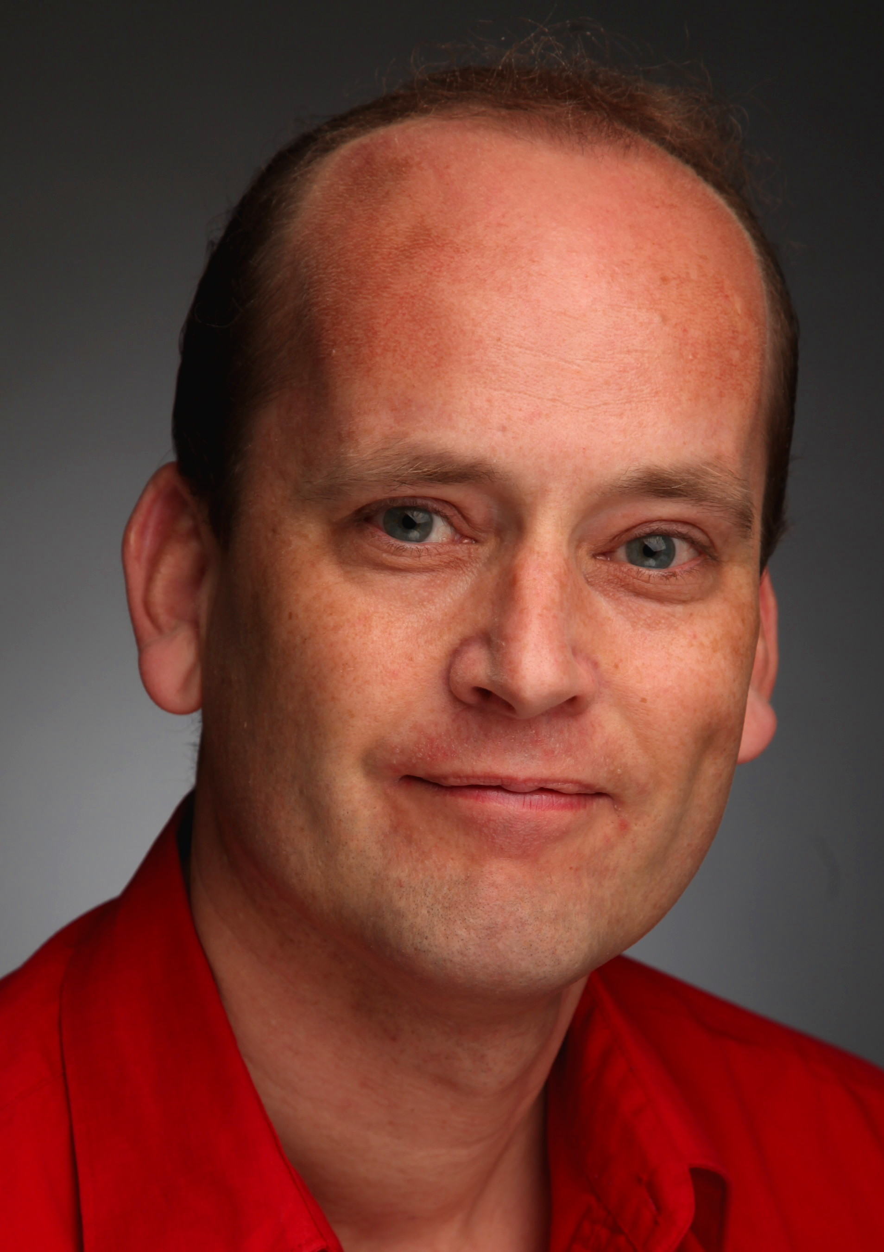
Rene Driessen
Rene Driessen Voice : Baritone
London SE28 Height : 6 foot / 1.83 m.
Spotlight viewpin :7919-0166-0827
Equity Member

rene.driessen@hotmail.com

Education

London Studio Centre London, Musical Theatre/Acting , Performer (BA)
Artez, Arnhem Higher School of the Arts, (BA) Theatre
----------------------------------------------------------------------------------------------------------------------------------------------------------------------------------------------------------------------------------------------------------------------------
Professional Skills Actor, Singer, Mover, Voice Over (and formerly also trained in dance)

Extra Skills

Stage-fighting, Ballroom & Latin Dancing, Tapdance (professional), Reading & Writing Music, Partnerwork
Drivers Licence : B (Passenger Car and Small Van)
Instruments : Rhythm Guitar and Piano (basic)
Languages : English, Dutch, Flemish, German (all fluent), French (intermediate)

Professional Experience
Recent credits : - Gert van de Graaf in new docu-film 'Take a Chance' (ABBA) for Amazon Prime
- Samuel Parker in new musical "The Last Queen of Paradise" (The Friendlysong Company)
- Hugo Gutmann in 'Hitler, the rise and Fall' for More 4 (UK TV) / AHC (USA TV channel)

Theatre

* Little Eyolf (Ibsen), Alfred Allmers  * Matilda and Geert (play), Geert (written by Mark Potter)  * Ghosts (Ibsen), pastor Manders  * Veltin’s Musical Revue (musical), Bernie (Comedy Lead), Germany  * Efteling Fairytale show2 (musical), Prince Eric (1st cover Lead) (dir: Frank Wentink)  * Hillbilly Hoedown (musical), Joey (dir: Kate des Blois)  * Castle Show (musical play), Edward (dir: Kate des Blois)  * Efteling Fairytale show1 (musical), King Stefan (Lead) (dir: Maria More, Bob Bouber)  * The Last Queen of Paradise, (musical), Samuel Parker, London  * Detrimental (play), Keith, Greenwich Theatre, London  * AIDA - opera in Ahoy, Rotterdam, Dance Ensemble (chor : Krzysztof Pastor)  * Miss Julie (Strindberg), Jean  * Rosmersholm (Ibsen), Kroll  * Hair (musical), ensemble, touring netherlands  * Nostradamus (dance show), Phantom, touring Netherlands  * Cabaret (musical), M.C.  * Let's Burn the Floor (dance), John  * The Dancing Courtyard, Courtier Henry, @ Arnhem monument  * Dinner Theatreshow, (musical), ensemble in Dordrecht  * Distressed Damsels (dance), Prince Rudolf, Theater Markant  * Sweet Charity (musical), ensemble Peacock Theatre, London (Dir: Jack Gunn)  * What the Butler Saw , Dr. Prentice, Peacock Theatre, London (Dir: Ian Dewar)  * Guys & Dolls musical selection (Dir: Jack Gunn), Sadler's Wells Theatre, London  * Sweet Charity, West Side Story, Kiss me Kate, 42nd Street  and Famous Feet selections touring, a.o. Arnhem City Theatre | Crowd Pleaser Theatre  Crowd Pleaser Theatre  Crowd Pleaser Theatre  Warner Bros Movie World  Endemol Entertainment  Disneyland Paris  Disneyland Paris  Maria More Entertainment  The Friendlysong Company  Vertical Line Theatre  Opera in Ahoy, Rotterdam  Crowd Pleaser Theatre  Crowd Pleaser Theatre  John Felter Productions  John Felter Productions  Drunick Studios  Drunick Studios  Lethdansant  Mystery  RD Productions  Seedtime  Seedtime  Seedtime  Artez

- 1 -
Rene Driessen
Professional Experience
Television

* Hitler, the Rise and Fall, Hugo Gutmann (Dir: S. Griffin)  * Parent Trap, PC Richard Barstow (Dir: N. Tebbet)  * Dispatches-Secrets from the cockpit, pilot (Dir: Claire Burnett)  * Hale & Pace, Abraham Lincoln (Dir: P. Orton)  * Una Voce Particulare, Juan (musical-singer) (Dir: S. v.d. Linden)  * Take-off (Soap), Tom Pieters (Dir: Lex Pieffers)  * The Life of Toon Hermans, Frans Jorissen (Dir: Maurice Hermans) | More4 & AHC (TV USA)  Discovery ID (TV USA)  Channel4 (2013)  LWT-TV  NCRV-TV  Veronica-TV  VARA-TV

Film

* Take a Chance (ABBA)  * Battlefield Lost  * Mathilda and Geert  * Cyber Me  * Moment of Thruths  * Rembrandt van Rijn  * Belle van Zuylen  * Two Dancers  * Good Will Hunting  * Smoke and Mirrors  * Dark Side of Business  * Mastering  * Gordon's Supermarkets  * Quafco  * No More Tradesmen  * Every Word Counts | Gert van de Graaf (VO) (dir. Max Hoskins)  German soldier and police officer (VO) (dir: Shaun Flynn)  Geert (dir: Mark Potter for Crowd Pleaser Theatre)  Johan (dir: Jason Edwards for CTN Ltd)  David and Clive (dir: Tom Hickmore)  Jean (dir: Charles Matton for Warner Bros Movies)  Michael (dir: Digna Sinke )  Christoph & Paul (V.O.) (dir: James Gardner)  (remake), Sean Maguire (dir: Ben Owora and for LFS)  Jan Kuyt (dir: Tim Parkman for Lessons Learned)  Jan Jaspers (dir: Tim Parkman for Lessons Learned)  Johann Hoffmann (dir: Tim Parkman for Lessons Learned)- Kees van Baasten (dir: Jason Harvey)  Farmer Ben Pieters (dir: Yann Caloghiris for Motion Collective)  Mr. Johnson (dir: Chris Pleydell)  Doctor Willems (dir: Valerie Dougall for Smile-on)

Commercial / Voice Over

Commercial  * Vivante (commercial), narrator (VO)  * First Day (commercial), Boss  * Airbus (2 commercials), flight passenger & diner * ONTV (promo), CEO Mr. Drayton  * ERU cheese (commercial), Knight Lance (fencing)  * NS (commercial), train passenger  Voice Over  * Take a Chance (film ABBA), Gert van de Graaf  * Battlefield Lost (film), German soldier & Police Officer  * Dispatches (TV) - Secrets from the cockpit, Pilot  * Two Dancers (feature film), Christoph & Paul  * Blind Spot (video dub), Todd  * The Yeti & The Russian dive (cartoon), Daniel & Alek  * Narrator Microsoft for several years  * Narrator Amazon for several years | Vivante (@ 2002 studios)  Champion Life Academy (dir: Katrina Mense-Chase)  Airbus / Making Pictures (dir : Dan Burn-Forti)  ONTV (dir: Paul Bennett)  ERU Cheese  NS (= Dutch national railways)  Amazon Prime (dir: Max Hoskins)  Sound Fiction Productions (dir: Shaun Flynn)  Channel 4 (dir: Claire Burnett)  James Gardner (dir: James Gardner)  Janus (@ 2002 Studios)  Janus (@ 2002 Studios)  Microsoft (@ 2002 Studios)  Amazon (@ 2002 Studios)

Semi-professional Experience

* The Wiz - Tinman  * Hair - Claude  * Jesus Christ Superstar - Jesus  * Once upon a time in a jukebox - Buddy Holly a.o.  * Pinocchio (ballet) - Featuring Role  * The Nutcracker - The Nutcracker  * Sweet Charity & Singin' in the rain (selections)  * Singer/Guitarist for 8 years | Group'78  Group'78  Group'78  Group'78  Drunick Studios  Studio Arabesque  Studio Arabesque  Several bands and Choirs

- 2 -

