Anthony Andre Jones, 65, grew up in Harlem, Spanish Harlem and Cambria Heights, Queens, New York. Jones has been in the entertainment industry for over 35 years and trained by his father, Jim. Jones started out as an independent club and concert promoter, but his ultimate goal/vision was to inspire youth and create an innovative entertainment empire and the realization of that vision has come to pass. He has been a community advocate, block association president, civic association member and president of the youth group at the Prince of Peace Lutheran Church in Cambria Heights, New York. Jones studied Business Administration at Baruch College in New York City, and then, served his country in the United States Air Force for almost 10 years. This allotted him the opportunity to travel the world, while still furthering and expanding his entertainment career. He promoted major concerts in London, England while on military tour (with Bob James and Earth, Wind & Fire), just to name a few and was also dubbed “the American D.J. in London”, while spinning at the prestigious “Penthouse Club” nightclub owned by Penthouse Magazine. After returning home from the military, Jones continued his education through university courses offered by the Veterans Administration. Jones has also been featured numerous times on television and radio networks and was even offered an opportunity to run for a political office, in which he declined.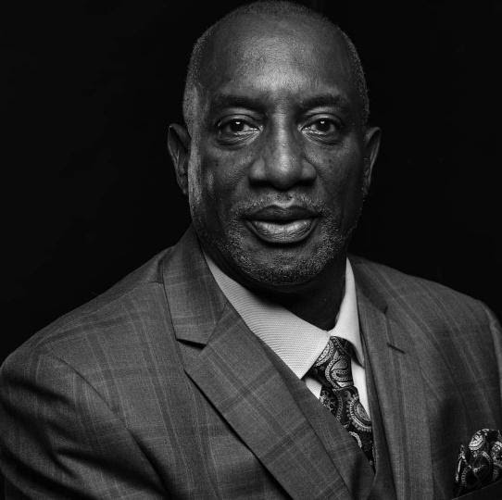
In June 2020, Jones was appointed as Vice-President, Reading Film Studios LLC. (www.readingfilmstudios.tv) and then in March 2021, Jones was appointed as Consultant/Director, Film T.V. Multimedia Productions, Cure Cancer With Music Inc. (www.curecancerwithmusic.org). Jones is truly inspired to be a part of such an amazing organization, as cancer is near and dear to him. There was a cancer cluster on his mother’s side of the family, amongst the brothers and sisters, in which four were diagnosed and a few have succumbed. He is excited and dedicated to helping those in need of hope and support, while navigating the fight against cancer by producing major concert series shows throughout the U.S. and overseas. “God has given me my appointed purposed positions and works”.
Jones was also the Property Manager at 531 Canal Street, Reading, PA, (a previously condemned building), which he oversaw the process of getting it back into compliance (building code), which was reopened between January 2020 - May 2020, before assisting with the build in and launching of the new startup Reading Film Studios, LLC, in which he is currently the Vice President. Jones is also the CEO, Chase Nelson Consultants International, LLC, which started in the early 2000’s. Chase Nelson Consultants has assembled an All-Star Executive Board of Directors from throughout the country to not just oversee the initiatives of the company, but to apply its diverse expertise and imagination to being policy makers, which is the driving force, for this company. Jones serves as a Consultant for many individuals and corporate entities. Jones has also made a key alliance and also partnered with James “CB” Gray and Timothy “Brewmaster” Davis of New York City, in which Gray and Davis are key players/partners and Senior Executives of Chase Nelson Consultants International.
Jones has established himself as a global presence and influencer and is partnering with several brand corporations, T.V. personalities, actors, producers, directors and industry giants to create impactful content that entertains and inspires global audiences. He has coordinated many events during his career; so many that it is hard to list them all. Film/TV Projects include: Co-Producer/Investor - Better Dayz Film Production Inc. – 1999 – “Better Dayz”; Producer/Investor. D & C Film Production, Inc. – 2000 – “Return of Fire”. T.V. Program Producer/Investor – 2014 – “Philadelphia International Interfaith Court TV Series”. Associate Producer – Living Word Family Church (www.lwfc.org) – 2014 – “Another Chance” (www.anotherchancethemovie.com); Location Manager – Living Word Family Church – 2015 – “Fat Chance” (www.lwfc.org). However, his most memorable was his co-sponsoring of a May 2003 event at The United Nations in New York City. His associate, Keith Beauchamp, produced a documentary on the killing of a black teen in 1955 “Emmett Till”. Till’s death enraged the nation and made worldwide news, and this event sparked the start of the Civil Rights Movement. Beauchamp uncovered enough unknown information that caused the U.S. Attorney General to reopen the case and was one of the biggest civil rights cases to be reopened in America. Jones, working with Ms. Catherine Claxton (Head of The United Nations Film Society); set up a viewing of the documentary for the Secretary General of the United Nations and the United Nations staff. During the evening’s presentation, he orchestrated various recording artists performances. The famed legendary groups, Blue Magic and the Persuaders, who are friends of Jones, performed some of their greatest, all time, old school hits. Also performing was his sister, Kim Jones and recording artist, Kristin Hoffman. “This event was very important to me” because I had an opportunity to meet, conversate and spend quality time with Emmett Till’s mother, Mamie Till, who came to New York City for a private viewing of the documentary prior to her passing. Jones was also blessed to have had a discussion with Mamie Till and her nephews (Emmett’s cousins), who were with him outside the store when the whistling at the woman occurred. They were also in the house when Emmett was drug out, taken and killed. This discussion (remarkably) was the first in which they had the opportunity to be in the same room to discuss the events of that horrific day. It was absolutely tearful and emotional and I felt truly blessed to be present. Jones also states that, “the showing of the documentary and the song presentations brought mixed emotions and was a platform for people to realize how we as a people and nation have suffered and survived”. For his zealous determination to get this documentary shown to the United Nations staff and invited guests, Jones was awarded a medal from world-renowned guru, Sri Chinmoy. The theme for this prestigious award “Lifting Up the World with A Oneness-Heart”, honors individuals of Inspiration and Dedication. Mr. Chinmoy conducted the Peace Meditation at the United Nations for the Secretary General and main staff. This award has only been given to some of the world’s greatest leaders, i.e., President Jimmy Carter, Mother Theresa, Carl Lewis and other prominent recipients.
Jones has made invaluable contributions to multimedia, film and television with experience in pre- production, production and post- production. He has developed marketing strategies, engaged media outlets and worked with executive producers in a multi-camera studio, kept contracts up-to-date, along with monitoring the production budget and approving expenditures.
Jones has 3 grown children, 10 grandchildren and is a Prince Hall Mason. His mantra - “We have no choice but to be brilliant in what we do, no choice!”
Photo credit by professional photographer Justyna Riviello - www.justynariviello.com

