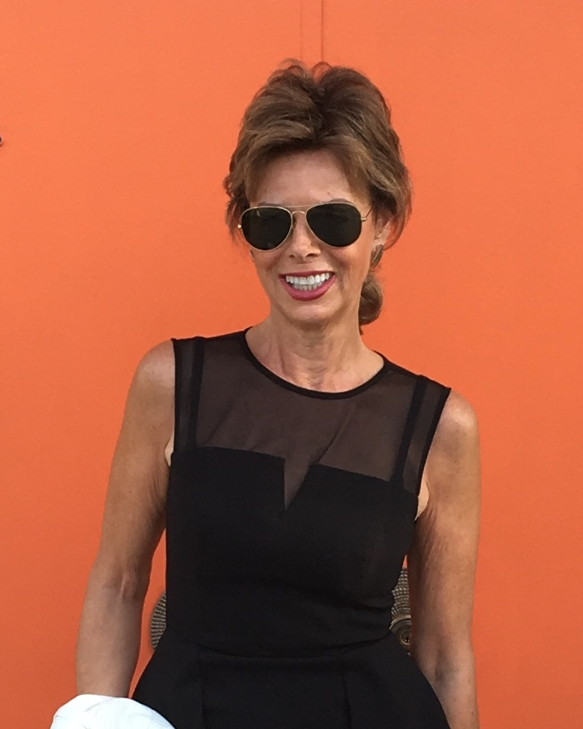

Orange Door Productions
A division of Worldwide Talent, Inc.

About Terri Lee Ryan

Terri began her career as an in-store model for Montgomery Wards. She worked as an on-air radio talent and news reporter for three years in Knoxville, TN. As a commercial actress and model throughout her adult life, she was multi-listed with Shirley Hamilton, Amelia Laurence, ARIA, David & Lee and Lily’s Talent Agency (LTA) in Chicago. Her clients included: Abbott Laboratories, State Farm and The Corner Bakery, where she did training films, drug roll-outs films, commercials and print work as a non-union on-air, voice and commercial print talent.

She received a B.A., Communications from the University of Tennessee and continued her training while attending classes at Act One, Ted Sarrantos and the Acting Studio, with a focus on on-camera and voice acting.

Terri was the executive producer of the 2014 documentary, “I Married a Cross-dresser” for Sky TV (Fox) in the UK. She was one of the few women producers and talent to win as finalist in the New York Television Festival (NYTVF), where her show, “Tails in the City” was a top five winner in the unscripted comedy competition (2012) and her show “Rori’s Party” was a Life Time TV top-five finalist (2014).

Currently she is doing voice acting while working on a new demo, along with looking for her next TV series concept to produce.

Terri Lee Ryan
terri@terrileeryan.com
www.terrileeryan.com
(760) 408-8891

